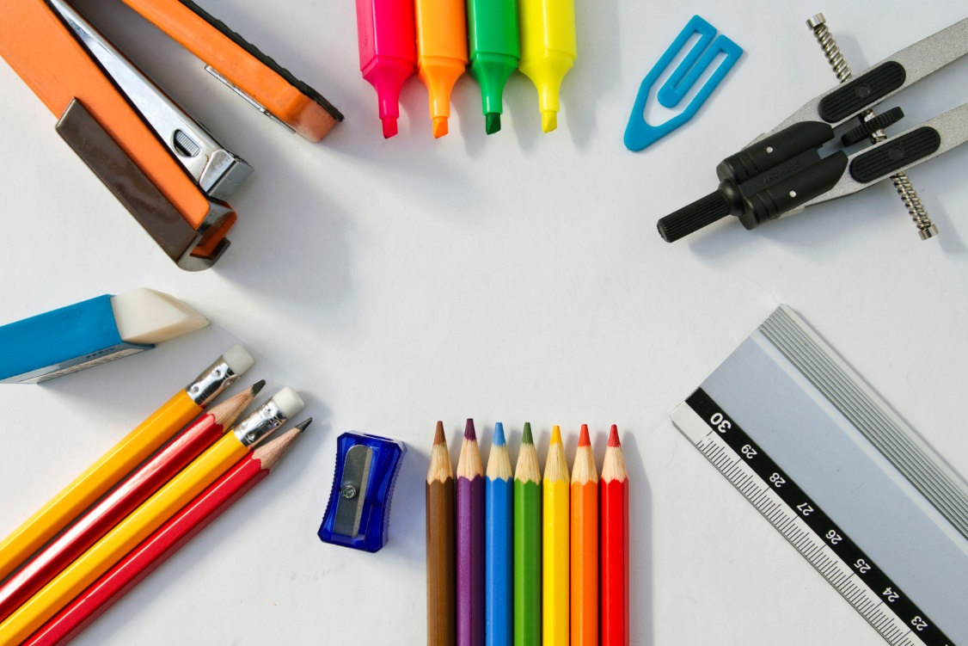

**\*Please put your child’s name on ALL supplies.**

**\*All Teachers will have supply baskets for students.**

**\*REPLACEMENT of supplies during the year is the student’s**

**responsibility.**

**4- Wide rule Spiral Notebooks**

**3- Plastic 2-Pocket folders (green, red and yellow)**

**2- Composition Notebooks**

**2- Wide-ruled Loose Leaf Paper**

**4- Boxes 1 Gallon Ziploc Bags**

**1- Box Sandwich size Ziploc Bags**

**4- Boxes of Kleenex**

**2- Pkgs. of Individual Kleenex**

**(Pocket Size)**

**2- Rolls of Paper Towels**

**2- Clorox Disinfectant Wipes**

**2- Bottles of Hand Sanitizer**

**1- Bottle of Liquid Soap**

**1- Book bag (no wheels)**

**1- Pair of gym shoes (to be left at school)**

**1- USB Flash Drive**

**1- Pencil Box**

**2- Boxes of No. 2 Pencils (24 count)**

**2- Colored Pencils 12ct**

**2-Highlighters**

**2- Red Erasable Ink Pens**

**2- Large erasers**

**1- Pack of Pencil tip Erasers**

**2- Boxes of Crayola Crayons 24ct.**

**2- Packs of Crayola Markers**

**4- Expo Dry erase Markers (black)**

**1- Pair of Blunt tip Scissors**

**12- Glue Sticks**

**1- Small Index Cards (lined)**

**1- Large Index Cards (lined)**

**Face Masks (Disposable or Reusable)**

**Headphones**